Q1) Identify the Data type for the Following:

Activity | Data Type
Number of beatings from Wife | Discrete
Results of rolling a dice | Discrete
Weight of a person | Continuous
Weight of Gold | Continuous
Distance between two places | Continuous
Length of a leaf | Continuous
Dog's weight | Continuous
Blue Color | Discrete
Number of kids | Discrete
Number of tickets in Indian railways | Discrete
Number of times married | Discrete
Gender (Male or Female) | Discrete

Q2) Identify the Data types, which were among the following
Nominal, Ordinal, Interval, Ratio.
Data | Data Type
Gender | Nominal
High School Class Ranking | Nominal
Celsius Temperature | Intervel
Weight | Ratio
Hair Color | Nominal
Socioeconomic Status | Intervel
Fahrenheit Temperature | Ratio
Height | Ratio
Type of living accommodation | Ordinal
Level of Agreement | Ordinal
IQ(Intelligence Scale) | Ordinal
Sales Figures | Ratio
Blood Group | Nominal
Time Of Day | Intervel
Time on a Clock with Hands | Intervel
Number of Children | Ordinal
Religious Preference | Nominal
Barometer Pressure | Intervel
SAT Scores | Intervel
Years of Education | Intervel- Ratio
Q3) Three Coins are tossed, find the probability that two heads and one tail are obtained?

If three coins are tossed,
Total number of possible combinations = 2³ = 8
The combinations are HHH, HHT, HTH, THH, TTH, THT, HTT, TTT.
Number of combinations that have two heads and one tail = 3, i.e., HHT, HTH, TTH
The probability of two heads and one tail when three coins are tossed simultaneously
P (Two heads and One tail) = Number of desired outcomes =3/8 or 0.375
Therefore, when asked, Three coins are tossed at once. What is the probability of two heads and one tail? then the answer will be that the probability of two heads and one tail is 3/8 or 0.375.

Q4) Two Dice are rolled, find the probability that sum is
- Equal to 1
- Less than or equal to 4
c) Sum is divisible by 2 and 3
a)
Ans.
If two dice are rolled, then total no of possible cases will be=36
Total favourable cases(having sum=1)=0
As minimum sum is 2 for outcome(1,1)=0
Hence probability is zero(0).

b) Less than or equal to 4
Ans.
The set of possible outcomes when we roll a dice are{1, 2, 3, 4, 5, 6}
So, when we roll two dice there are 6 × 6 = 36 possibilities.
When we roll two dice, the possibility of getting sum of number 4 is (1, 3), (2, 2), and (3, 1).
less than four is (1,1), (1,2), (2,1).
So,
The number of favorable outcomes = 6
Total number of possibilities = 36
Probability = The number of favorable outcomes / Total number of possibilities
Probability=6/36
=1/6

c) Sum is divisible by 2 and 3
Ans.
Total number of possible outcomes = 36
Favorable outcomes = sum is divisible by 2 and 3
Sum should be divisible by both 2 and 3
Favorable outcomes = (1 ,5), (3 ,3) , (4 , 2) , (5 , 1) , (6 , 6)
Therefore,
Number of favorable outcomes = 5
Probability = Total number of possible outcomes
Favorable outcomes

= 5/36
The probability of sum is divisible by 2 and 3 is 5/36.

Q5) A bag contains 2 red, 3 green and 2 blue balls. Two balls are drawn at random. What is the probability that none of the balls drawn is blue?
Ans.
A bag contains 2 red 3 green and 2 blue balls, Two balls are drawn at random.
Probability = favorable outcome/total outcome
None of the balls drawn is blue, this can only happen when the two balls
drawn at random are either red and green or both.
Total number of balls = 2 + 3 + 2 = 7
Number of ways of drawing 2 balls out of 7 =⁷C₂= (7 × 6) / (2 × 1) = 42/2 = 21
Number of ways of drawing
2 balls out of 5 =⁵C₂= (5 × 4) / (2 × 1) = 20/2 = 10
Probability = 10/21

Q6)
Calculate the Expected number of candies for a randomly selected child
Below are the probabilities of count of candies for children (ignoring the nature of child-Generalized view)

CHILD | Candies count | Probability
A | 1 | 0.015
B | 4 | 0.20
C | 3 | 0.65
D | 5 | 0.005
E | 6 | 0.01
F | 2 | 0.120
Child A – probability of having 1 candy = 0.015.
Child B – probability of having 4 candies = 0.20

Ans.
Expected number of candies for a randomly selected child
= 1 * 0.015 + 4*0.20 + 3 *0.65 + 5*0.005 + 6 *0.01 + 2 * 0.12
= 0.015 + 0.8+ 1.95 + 0.025 + 0.06 + 0.24
= 3.090
=3.09
Expected number of candies for a randomly selected child = 3.09

Q8) Calculate Expected Value for the problem below
- The weights (X) of patients at a clinic (in pounds), are
108, 110, 123, 134, 135, 145, 167, 187, 199
Assume one of the patients is chosen at random. What is the Expected Value of the Weight of that patient?
Ans.
Expected Value = ∑ (probability * Value )
∑ P(x).E(x)
there are total 9 patients
Probability of selecting each patient = 1/9
Ex 108, 110, 123, 134, 135, 145, 167, 187, 199
P(x): 1/9 1/9 1/9 1/9 1/9 1/9 1/9 1/9 1/9
Expected Value = (1/9)*(108) + (1/9)*110 + (1/9)*123 + (1/9)*134 + (1/9)*135 + (1/9)*145 + (1/9)*167 + (1/9)*187 + (1/9)*199
= (1/9) * ( 108 + 110 + 123 + 134 + 135 + 145 + 167 + 187 + 199 )
= (1/9) * ( 1308 )
= 145.33

145.33 is the Expected Value of the Weight of that patient.

10) Draw inferences about the following box-plot & histogram?
Ans.

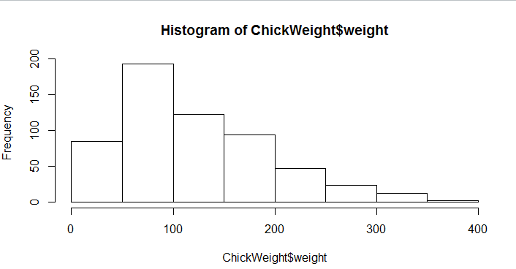

Inference Of Above Histogram :
From the above histogram we can say that the data is positively skewed.
In case of a positively skewed frequency distribution, the mean is
always greater than median and the median is always greater than the mode.
In this case mean > median > mode.

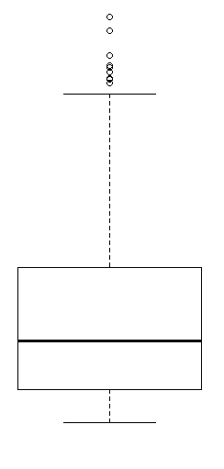
Inference Of Above Box-plot:
Median is less than mean right skewed and we have outlier on the upper side of
box plot and there is less data points between Q1 and bottom point
.
Q11) Suppose we want to estimate the average weight of an adult male in Mexico. We draw a random sample of 2,000 men from a population of 3,000,000 men and weigh them. We find that the average person in our sample weighs 200 pounds, and the standard deviation of the sample is 30 pounds. Calculate 94%,98%,96% confidence interval?

Ans.
X-(Z1-α.σ/sqrt(n))
Degrees of freedom= 2000-1= 1999
Confidence interval= 94%
(1-σ/2)= 1-0.03) =0.97
for Confidene interval for 94% is 1.882
Confidence interval for 98%= 2.33
Confidence interval for 96% = 2.05

Q12) Below are the scores obtained by a student in tests
34,36,36,38,38,39,39,40,40,41,41,41,41,42,42,45,49,56
1) Find mean, median, variance, standard deviation.
2)What can we say about the student marks?
Ans. Mean= 41.0 , Median= 40.5, Variance=24.111, Standard deviation=4.9103
From the scores obtained in student test 49,56 are mostly are outliers.

Q13) What is the nature of skewness when mean, median of data are equal?
Ans. When mean and median of data re equal then the nature of skewness is zero.

Q14) What is the nature of skewness when mean > median?
Ans. If the mean is greater than the median, the distribution is positively skewed.

Q15) What is the nature of skewness when median > mean?
Ans. When median > mean the skewness and tail is towards left.

Q16) What does positive kurtosis value indicates for a data ?
Ans. Positive values of kurtosis indicate that distribution is peaked and possesses thick tails. An extreme positive kurtosis indicates a distribution where more of the numbers are located in the tails of the distribution instead of around the mean.

Q17) What does negative kurtosis value indicates for a data?
Ans. A negative kurtosis means that your distribution is flatter than a normal curve with the same mean and standard deviation.

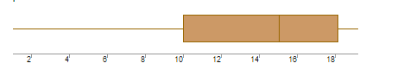

Q18) Answer the below questions using the above box-plot visualization?
- What can we say about the distribution of the data?
- What is nature of skewness of the data?
- What will be the IQR of the data (approximately)?

Ans.
From the above box-plot visualization we can say that the data is not
normally distributed its left skewed.

IQR = Q3-Q1
IQR=18-10 = 8
Hence Inter-quartile Range(IQR) of the above box-plot is 8 (approximately).

Q19) Comment on the below Box-plot visualizations?
Draw an Inference from the distribution of data for Box-plot 1
with respect Box-plot 2?

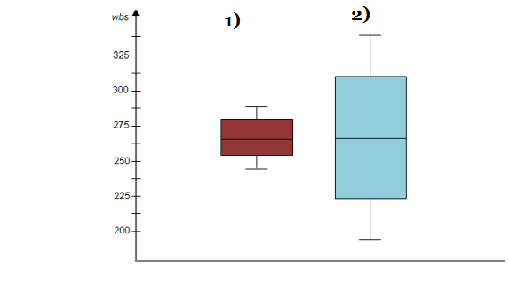

Ans.

- Median for Boxplots1 & Boxplot2 is to be appears approximately 262.5
- Data in Boxplot2 is more Scattered as compared to Data in Boxplot1.
- Boxplot1 range from a low of 240 to a high of 287, so their range is 287−240=4, whereas Boxplot2 range from lowest score is 180 and the highest approximately is 350, so their range is 350−180=170.
- In Boxplot1 data points consistently hover around the center values that means less variable data in Boxplot1, whereas Boxplot2 imply more variable Data.

Q 22) Calculate the Z scores of 90% confidence interval,94% confidence interval, 60% confidence interval

Ans:
Confidence interval | Z scores
60% | 0.253
90% | 1.645
94% | 1.555

Q 23) Calculate the t scores of 95% confidence interval, 96% confidence interval, 99% confidence interval for sample size of 25
Ans:
Confidence interval | t score
95% | 2.262
96% | 2.171
99% | 2.796

Q 24) A Government company claims that an average light bulb lasts 270 days. A researcher randomly selects 18 bulbs for testing. The sampled bulbs last an average of 260 days, with a standard deviation of 90 days. If the CEO's claim were true, what is the probability that 18 randomly selected bulbs would have an average life of no more than 260 days
Hint:
rcode pt(tscore,df)
df degrees of freedom
Ans:
t-statistics for the data is given as follows:
x = sample mean = 260
µ=population mean=270
s=standard deviation of the sample=90
n= number of items in the sample = 18
t =

t =
t =
t =
t =
t = -0.471

For probability calculations the no of degrees of freedom is n-1, so here you need the t-distribution with 17 degrees of freedom.
The probability that t<-0.471 with 17 degrees of freedom assuming the population mean is true, the t-value is less than the t-value obtained with 17 degrees of freedom and t score of -0.471, the probability of bulb lasting less than 260 days on average of 0.3218 assuming the mean life of the bulbs is 300 days.

